**Project Initialization and Planning Phase**

| Date | 5 August 2025 |
| --- | --- |
| Team ID | xxxxxx |
| Project Name | Predicting Plant Growth Stages Using Environmental & Management Data in Power BI |
| Maximum Marks | 3 Marks |

**Define Problem Statements (Customer Problem Statement Template):**

For my project, the focus is on farmers, agronomists, or greenhouse managers who want to accurately predict plant growth stages based on data such as temperature, humidity, sunlight hours, watering frequency, fertilizer type, and soil conditions. By visualizing and analyzing this data in Power BI, they can make timely decisions to improve crop yield and resource use.

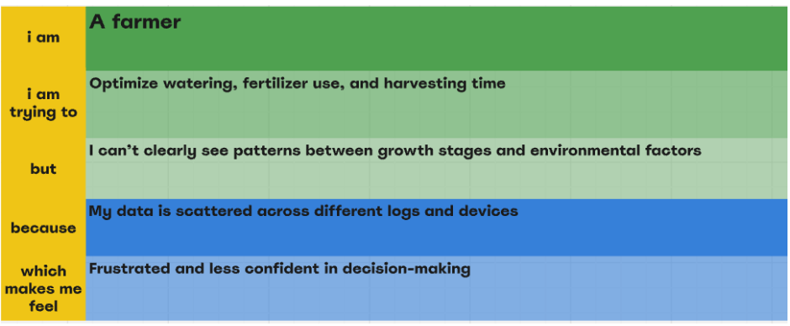

|  |  |  |  |  |  |
| --- | --- | --- | --- | --- | --- |
| **Problem**  **Statement (PS)** | **I am**  **(Customer)** | **I’m trying to** | **But** | **Because** | **Which makes me feel** |
| PS-1 | A greenhouse manager | Predict the growth stage of plants in real time | My current tracking is manual and inconsistent | I don’t have an easy way to combine and visualize all environmental and management data | Uncertain and stressed |
| PS-2 | A farmer | Optimize watering, fertilizer use, and harvesting time | I can’t clearly see patterns between growth stages and environmental factors | My data is scattered across different logs and devices | Frustrated and less confident in decision-making |